TECHNOLOGICAL ADVANCEMENT IN MUSIC
STUDENTS NAME
INSTITUTION
DUE DATE
ABSTRACT
Apart from being present in live performances it is not easy to even process the fact that, in over a century ago, the regular being did not have laidback means to get songs regularly. The melodious universe upgraded so much through the 20th century, thanks to the popularization of belongings like radio, TV, and private song players.
Entering into the novel epoch yet, was the contemporary musical high-tech bang that truthfully transfigured the music industry. Educational progress, streaming services, artificial intelligence, on net music making, and more — these have redesigned the music industry.
TRANSFORMATION IN MUSIC EDUCATION
One of the crucial parts where technology is renovating the music world most is in the industry of music tutoring. However, the impression of fresh musical technology often raises feelings of things like new-fangled recording studio one apparatus or a board of cutting-edge guitar pedals
For instance, there exist many apps accessible that update the normal music teacher’s capability to explain to their pupils. Recording applications such as Garageband, drum machines applications similar with DM1 The Drum Machine, and even applications designed for fresher players such as Loopimal all let pupils to acquire knowledge about music in new, actual habits.
The overabundance of new application driven erudition gears also give scholars hands-on contact to abilities like composing songs and recording them. These gears allow music teachers to help their pupils be dynamically involved in their schooling. On top the fact that basic applications like Cleartune and TonalEnergy can even permit a budding artist to air their device with not more than their smartphones, and it becomes distinct that present music schooling has remained obstructed for the better.
MUSIC ALLIANCE
Modern technology is revolutionizing the musical landscape in another manner that is by bringing together artists and recording studios deprived of the need to be extant in the same place.
Revolutionary skills like Source Connect are permitting singers to “beam in” their soundtracks right to production studios with just connecting to the internet. The expansion offers the aptitude for anybody connected to acquire contact to any kind mixing and mastering facilities they may need without ever requiring to pack up their tools or even leave the households.

STREAM-LINING AND LISTENING EXPERIENCE
The capability to practically listen to any song by any singer without a cassette, CD, or even a home-grown MP3 file is one obvious modern music trend. Flowing applications such as Deezer, Spotify and Pandora have advanced systems that outshine at corresponding operators with songs corresponding their musical likings. The technically heightened idea of crowdsourcing has impacted as well. Take, for instance, this list of "afternoon slump" song assortments that was fashioned by voting the Timmermann Group office for recommendations.
Additionally, applications, for instance Shazam even let hearers to locate precisely what song they are following to enlarge their musical shrewdness and permit them to look up a specific song to listen in the future.


ENGAGING THE CROWD
Providing quality user experiences is part of the modern marketing "secret sauce" which includes engaging them by means of online networks. And though this is valid in all fields of publicising, music has been impacted.
One of the utmost instances of the application an engaging musical advertising campaign arose in the form of Childish Gambino’s 2016 issue of “Awaken, My Love!” The vinyl form of the folder came finished that permitted operators to experience a 3D recording of a live presentation of the album. This gave an exclusive, in-depth operator involvement that resounded with clients and created buzz.

ARTIFICIAL INTELLIGENCE
Technology is not only helping with music production, but also even writing and recording the music itself. Though musical structures have been assisted by artificial intelligence for many years, artificial intelligence produced and complete song and music video all on its own as lately as early 2018. While not necessarily Billboard Top 100 quality, the accomplishment validates that artificial intelligence is swiftly refining to the point where the notion of scripting epic musical numbers might rapidly be abridged to little more than a process.

MUSIC ACCESIBILITY.
The influx of millennials on the music scene in force upset the status quo with music as much as it did with everything else. Millennials listen to a astounding 75 percent additional music than baby boomers. That combined with the uncountable new ways that knowledge has abridged music elevation networks, and the whole act is a match out of this world.
The accessibility of so many streaming facilities is part of the reasons why music can be so readily disbursed today. Though we previously stated how facilities like Spotify, Pandora, Apple Music, Amazon Unlimited, Google Play, and so on aid match music viewers to their favourite choices, it also lets clients to acquires the whole world of music without ever having to buy an album.
The growth of the on net music market, and streaming facilities, precisely, have been seriously used. Though majority of the firms presently giving these facilities are functioning in the red, the absolute status of the new way to present music implies that one way or another, the technology will stay.

Music consumption habits have changed
How we utilise music has totally evolved. We now have paid subscriptions to online streaming platforms on our portable devices giving us millions of songs at our fingertips, where once there was peer-to-peer sharing of music files from sites like LimeWire and high demand for MP3 players. Tangible music sales have reduced swiftly – there were 32 million compact disks sold in the UK in 2018. This figure was however 132 million compact disks in 2008.
This pattern shift has not occurred instantly but has definitely enhanced in the previous few years. For example Spotify, in 2016 its number of paid subscribers worldwide tripled from 30 million to more than 100 million in 2019. Apple Music has the same story, debut in 2015 and now is proud to have 60 million salaried operators internationally Spotify, Apple Music, and their fast growth designate a change in customer anticipation for music anytime and anywhere
Platforms like YouTube Music, Soundcloud, Pandora, and Tidal are likewise deeply used and you might argue that streaming platforms have become so global they can now be broken down by use-case – e.g. extensive catalog, independent artist discovery, passive listening or restored audio quality.
Their algorithmic foundations, using machine learning to work out the music preferences and listening habits of their users are some of the things these platforms have in common. This, combined with the platforms’ optimizing and prioritizing UX, we’ve come in the fresh world of songs unearthing.
The main streaming platforms have done a good job of providing their users the music they want in the form of personalized, curated, and exclusive playlists.
THE IPOD
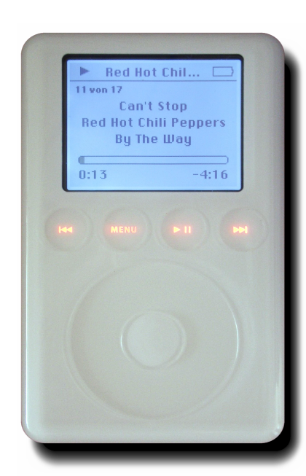Steve Jobs’ brilliant knowledge for a smooth, simple mp3 player played and significant and synergetic part in the development of the MP3 and distribution of records. The device developed to be so prevalent that main record labels finally succumbed to digital distribution models. With singles sold at just 99 cents each, that represented a major cut in the revenues, a loss from which legacy record labels are still fraught to recover.
This one, fashionably created mp3 player remained the substance for abundant change in the music industry, only by making the request for a creation for which the only prior supply was unlawful copying. This was one invention the entire music industry writhed to keep up with and created an almost prompt revolt with technology that was gladly accessible.

WORKS CITED
Molteni, Luca, and Andrea Ordanini. "Consumption patterns, digital technology and music downloading." Long Range Planning 36.4 (2003): 389-406.
Dammers, Richard J. "Technology-based music classes in high schools in the United States." Bulletin of the Council for Research in Music Education 194 (2012): 73-90.#
Garofalo, Reebee. "From music publishing to MP3: Music and industry in the twentieth century." American music (1999): 318-354.

